Macrofrozen Notification
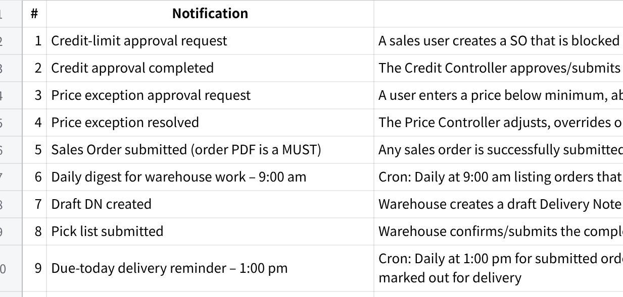
点击图片可查看完整电子表格

Common behaviour for every notification
Every triggered notification should:
- Be written into the relevant document’s Activity Trail, including trigger, timestamp, actor/cron, recipients and outcome.
- Be injected into the recipient’s MAIA chatbot
- Include a direct link to the relevant document.
- Attach the PDF where operationally required: Sales Order, Delivery Order
- Avoid duplicate alerts to the same person.
- Record whether delivery succeeded or failed.
- Close approval loops by notifying the original requestor after action is taken.

Things to clarify with clients about the notification
- macrofrozen total sales using invoice or so?
- need to include the return (CN) or deduct it?
- revenue should belong to whom (assignee or owner)?

